Project Design Phase-II
Data Flow Diagram & User Stories

Date | 26 June 2026
Team ID | Solo
Project Name | ShopEZ - E-Commerce Application
Maximum Marks | 4 Marks

Data Flow Diagrams:
A Data Flow Diagram (DFD) is a traditional visual representation of the information flows within a system. A neat and clear DFD can depict the right amount of the system requirement graphically. It shows how data enters and leaves the system, what changes the information, and where data is stored.
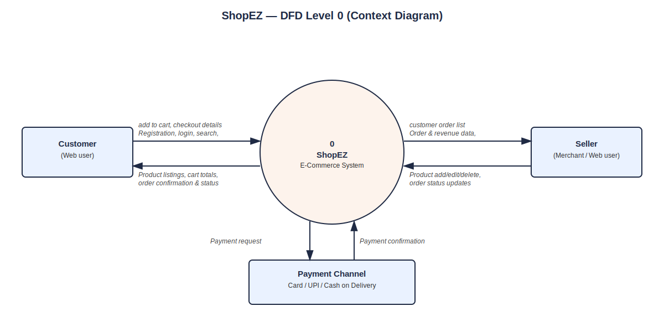

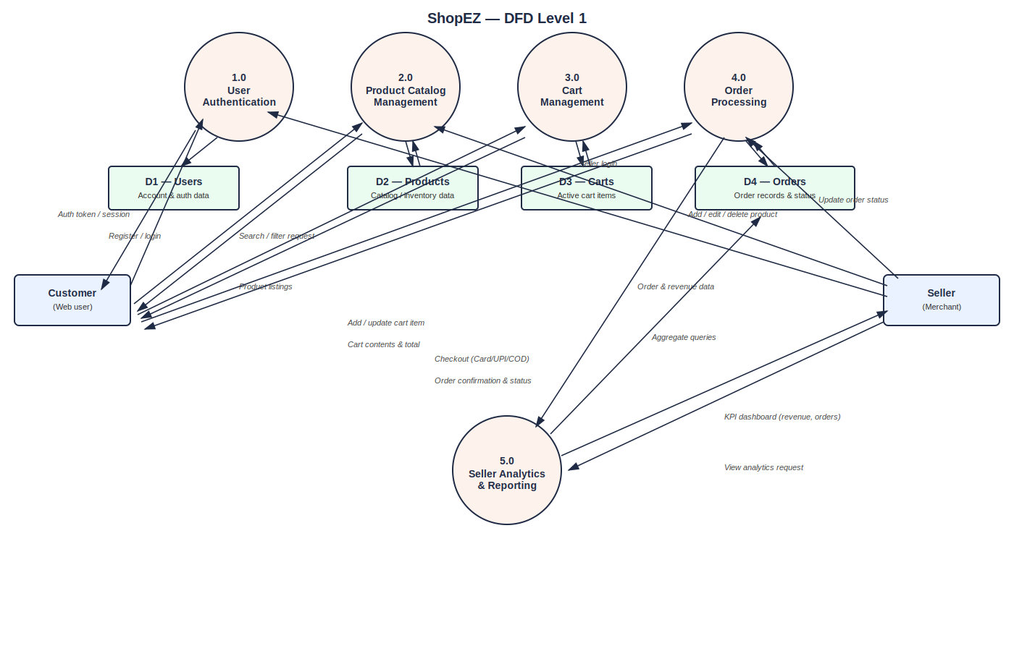
User Stories
Use the below template to list all the user stories for the product.
User Type | Functional Requirement (Epic) | User Story Number | User Story / Task | Acceptance criteria | Priority | Release
Customer (Mobile user) | Registration | USN-1 | As a user, I can register for the application by entering my email, password, and confirming my password. | I can access my account / dashboard | High | Sprint-1
Customer (Web user) | Login | USN-2 | As a user, I can log into the application using my email and password | I am redirected to the homepage on success | High | Sprint-1
Customer (Web user) | Catalog Browsing | USN-3 | As a user, I can search products and filter by category | I see matching products update live | High | Sprint-1
Customer (Web user) | Product Details | USN-4 | As a user, I can view a product's specifications and customer reviews in separate tabs | I can switch tabs and see correct content | Medium | Sprint-2
Customer (Web user) | Cart Management | USN-5 | As a user, I can add, remove, or update quantity of items in my cart | Cart total updates instantly and syncs to my account | High | Sprint-2
Customer (Web user) | Checkout | USN-6 | As a user, I can complete checkout in 3 steps and pay via Card, UPI, or Cash on Delivery | I receive an order confirmation with an order ID | High | Sprint-2
Customer (Web user) | Profile Management | USN-7 | As a user, I can edit my saved addresses and view my order status history | Updated address is saved; order statuses display correctly | Medium | Sprint-3
Seller (Web user) | Login | USN-8 | As a seller, I can log into my seller dashboard using my email and password | I am redirected to the dashboard on success | High | Sprint-1
Seller (Web user) | Inventory Management | USN-9 | As a seller, I can add, edit, or delete a product via a form modal | Product list reflects changes immediately | High | Sprint-2
Seller (Web user) | Order Management | USN-10 | As a seller, I can search orders by ID and update their status | Order status updates instantly and is visible to the customer | High | Sprint-3
Seller (Web user) | Analytics Dashboard | USN-11 | As a seller, I can view live KPI cards for total revenue, total orders, pending orders, and delivered orders | KPI values match current order data | Medium | Sprint-3

